APPENDICES

Contents

APPENDIX A: Hardware pictures II

Previous design II

Mark I III

Mark II IV

Piston mechanism V

New Launcher designs VI

Demo prototype main view VII

Prototype’s chassis structure VIII

Different views of the prototype IX

APPENDIX B XI

Construction Reports XI

Version 1 XI

Version 2 XIII

Result XIV

# APPENDIX A: Hardware pictures

## Previous design

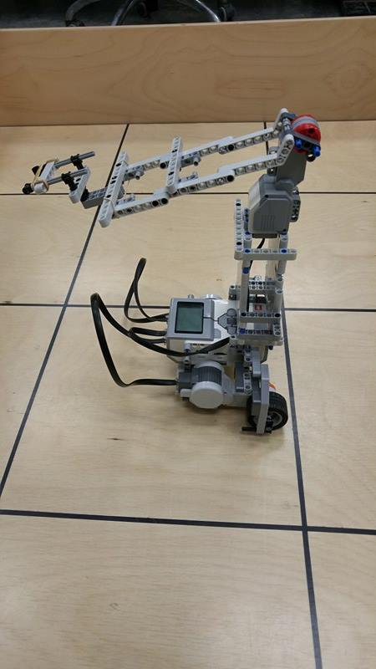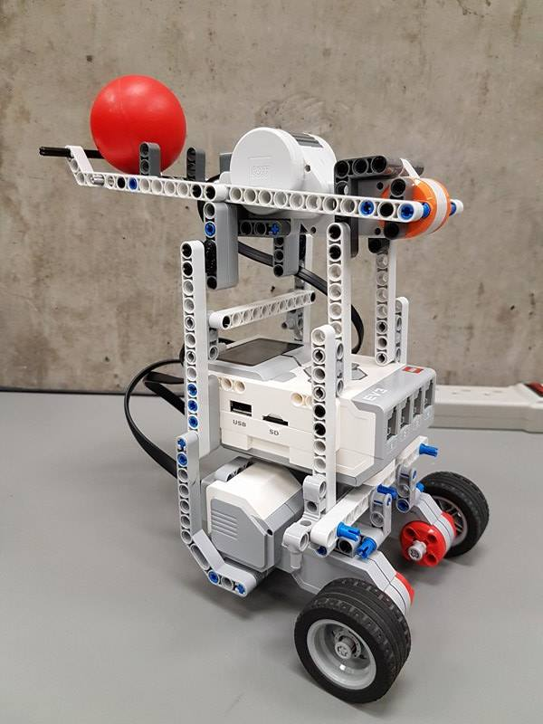

Figure 1

Figure 2

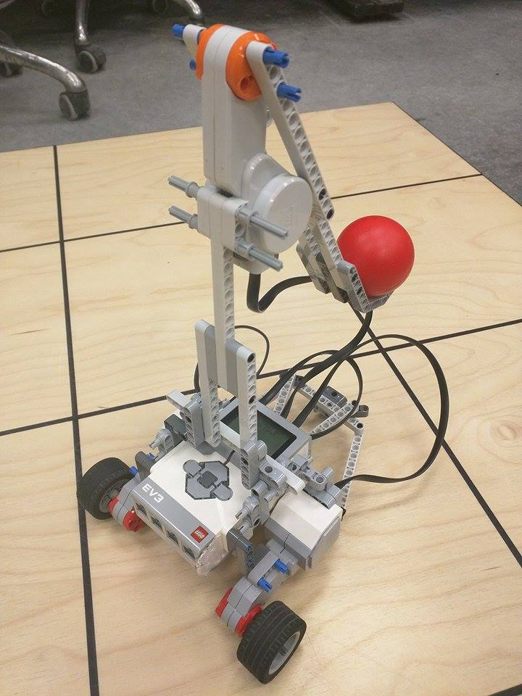

Figure 1, 2 and 3: These are the designs used by the individual teams for Lab 5. All used a catapult design because of its simple mechanism. We used the robot of figure 3 as a start for Mark I. We built the tower on top of it, and gradually disassembled the other two for the parts.

Figure 3

## C:\Users\Philippe\Downloads\First Model.jpgMark I

Figure 4: This is the first design of the robot. The massive catapult arm takes most of the space, and at that time there was no second brick in the back. When shooting, the robot moved slightly forward and the arm flexed.

The robot also had a mediocre ball collecting system composed of rail on the left side. Under the blue ball, there was a medium motor connected to an “L” shaped piece. When rotating 90°, it pushed the first ball in the catapult cup. The second ball would go down, but was stopped from falling by the motor

We intended to use the central motor for the defense mechanism. It was dropped in the later version.

Note: the tower of the catapult has no cross member and is only composed of a center piece.

Figure 4

## https://scontent.fyhu1-1.fna.fbcdn.net/v/t34.0-12/17361167_845301885609176_337536277_n.jpg?oh=1369748f98e0a9bcc592b32c6541c478&oe=58D215F0Mark II

Figure 5: This is the main view of Mark II, which was a big step forward. The tower was enormous: at least 25 cm higher than Mark I. To support all this weight, we added numerous cross members and 45° pieces.

The second brick was added on the small flat piece in the back of Mark I. The arm was smaller compared to Mark I, which posed numerous problems with the reloading mechanism. Since at that time we didn’t have the specs of the dispenser, we decided to concentrate on other issues.

Figure 5

## https://scontent-yyz1-1.xx.fbcdn.net/v/t34.0-12/17760291_10208903822767946_557750020_n.jpg?oh=c33aa33a0271124236fd58ca208da41a&oe=58E3F74BPiston mechanism

Figure 6 and 7: A piston mechanism prototype designed in parallel with the catapult launcher. The large motor created a crankshaft mechanism. The flat surface pushed the ball between the two 45° pieces. These pieces flexed and eventually pushed the ball out of the chamber.

Figure 6

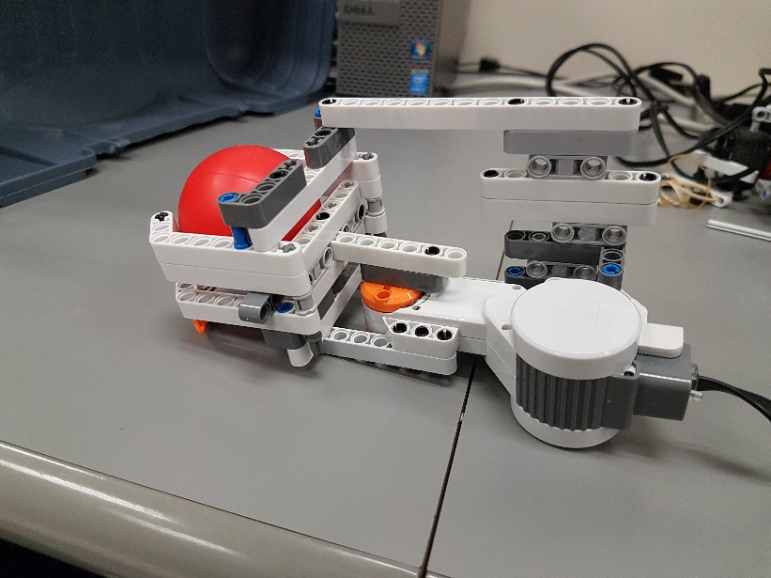

Figure 7

## https://scontent.fyhu1-1.fna.fbcdn.net/v/t34.0-12/17274559_845301865609178_796155582_n.jpg?oh=3a7d9ffa1d20bdbbaa91cbd5db437c75&oe=58D200FCNew Launcher designs

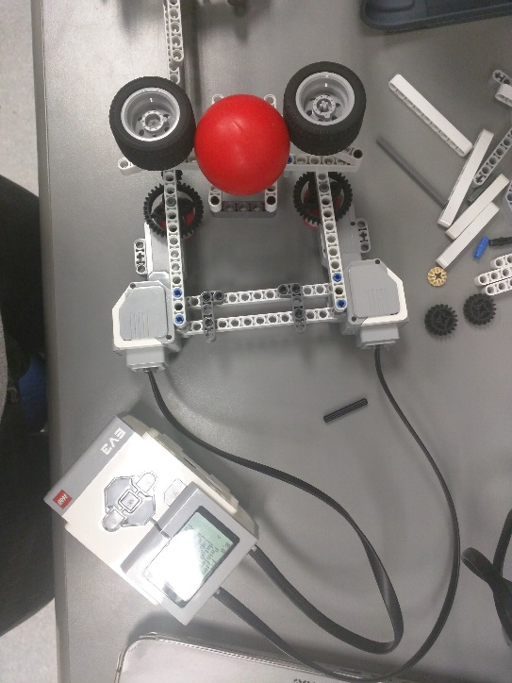

Figure 8

Figure 9

Figure 8 and 9: After trying the catapult, we wanted to know if we could build a better mechanism. First, we revisited an old mechanism from lab 5: the spinning wheels. We needed to adjust perfectly the distance between the wheels, so the ball could slide just the right amount, while not getting stuck. The structuring below the wheels needed to be rigid to keep the wheel distance constant. In Figure 9, we see the gear mechanism used to greatly increase the speed at the expense of the torque.

## Demo prototype main view

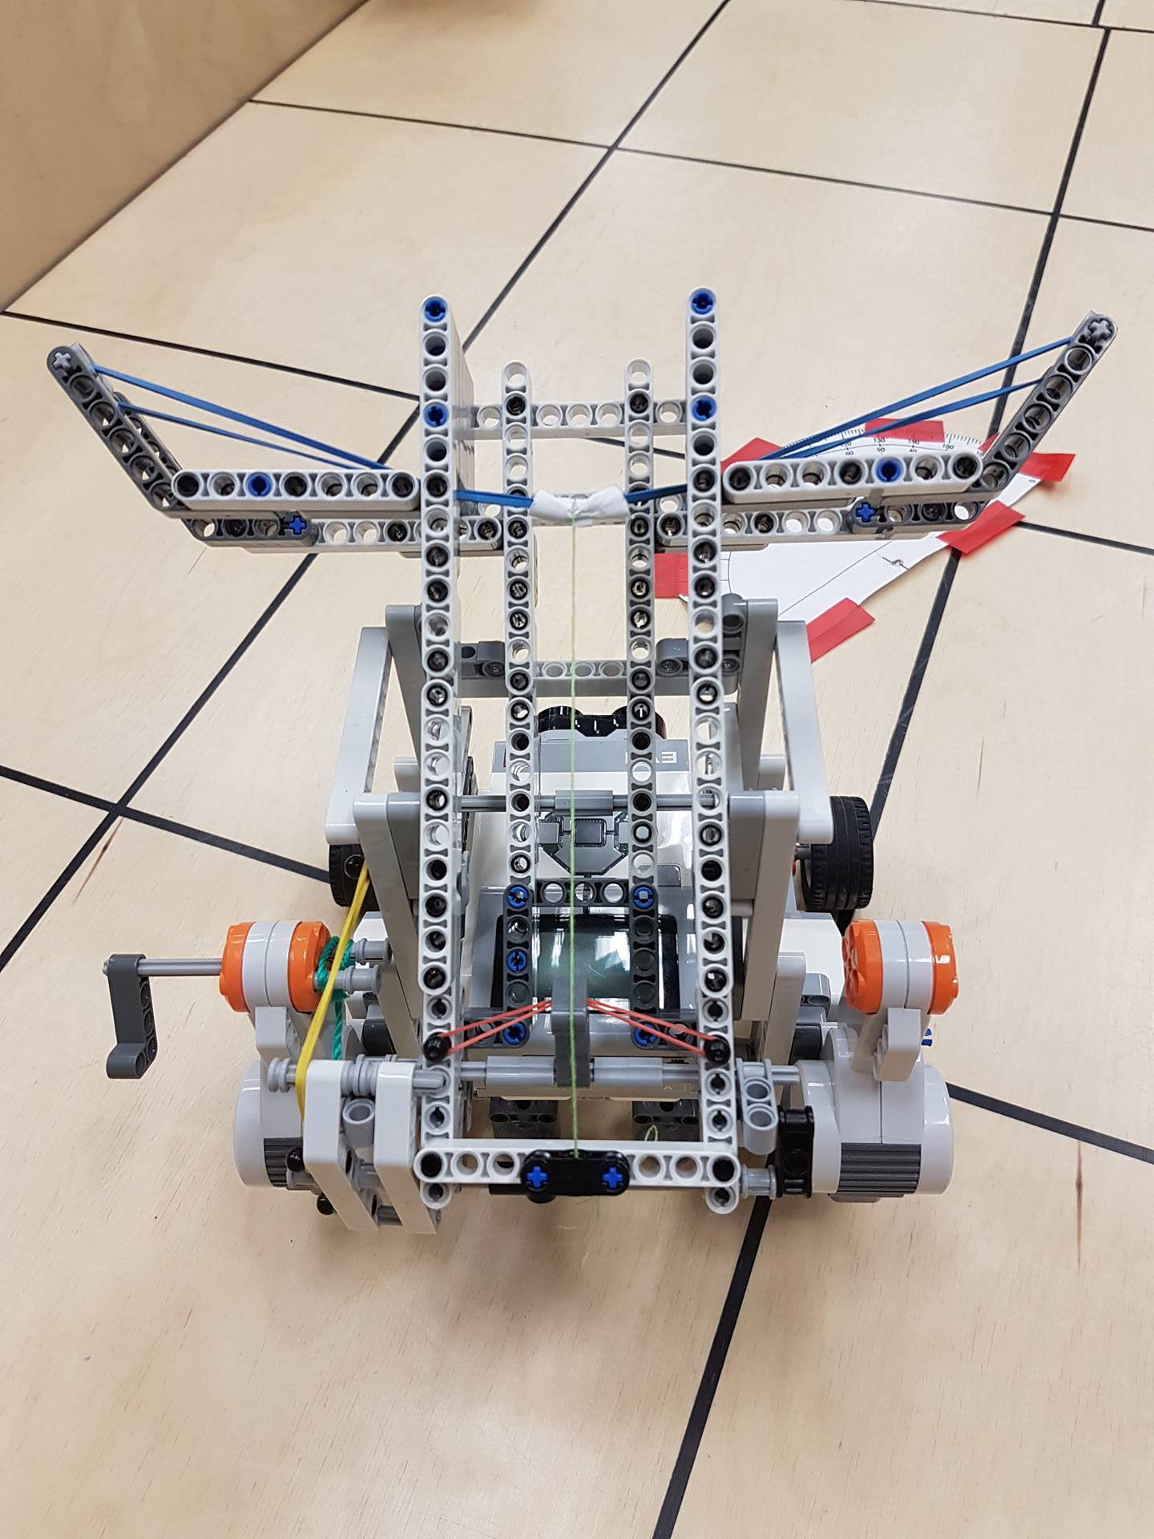

Figure 10

Figure 10: This is a top view of the crossbow prototype for the demo on 24/03/2017. From this point of view, you can easily see the main features: lighter string for reloading, paper to distribute the weight on the blue rubber band, trigger on the left. The trigger is still not connected to the right motor.

## Prototype’s chassis structure

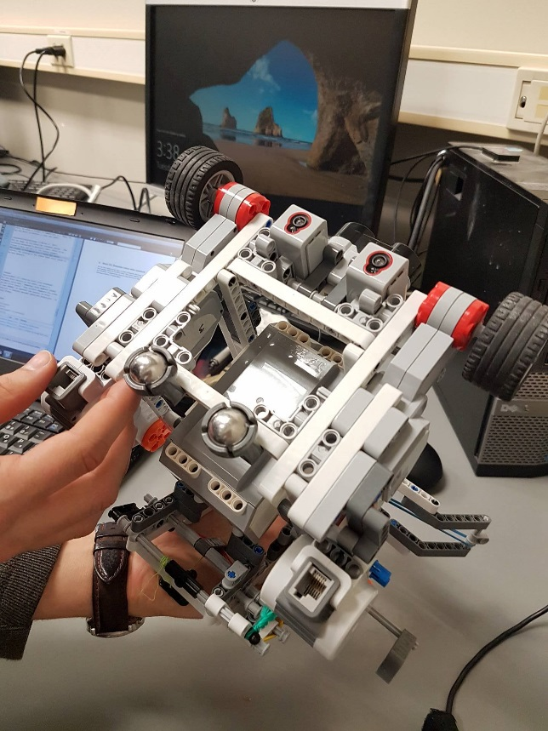Figure 11: This is a bottom view of the chassis. The main beams are sandwiched between cross pieces (center of the chassis) and the motors. A piece runs in the middle connection of the motor to connect with the main beam through an “H” shaped piece.

Figure 11

## Different views of the prototype

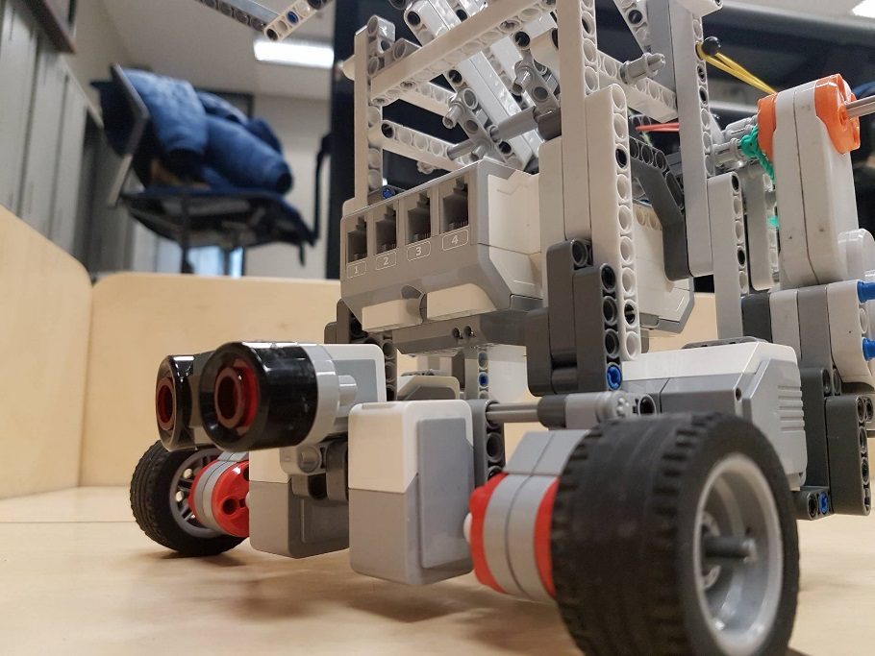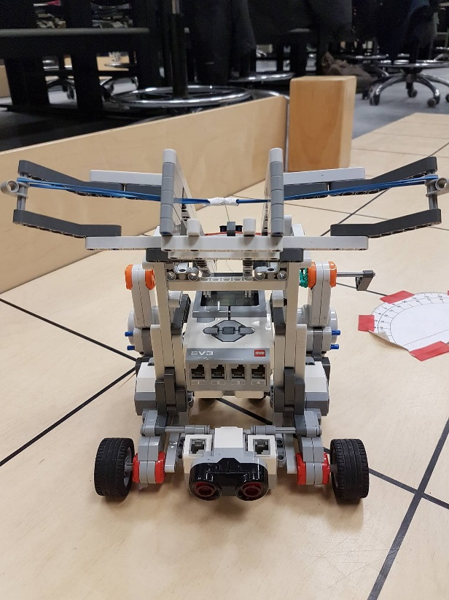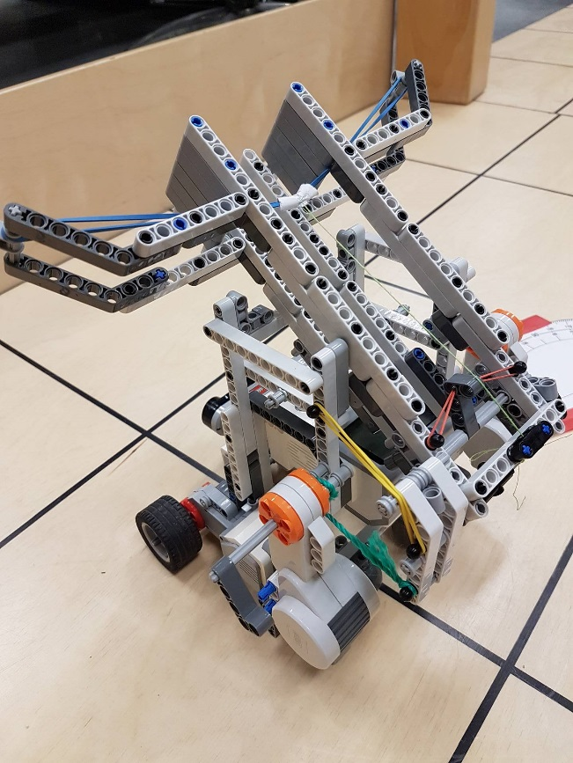Figures 12, 13 and 14: Different views of the demo prototype. The crossbow allows the user to change the angle of inclination, which affects the x and y speed of the ball.

Figure 12

Figure 14

Figure 13

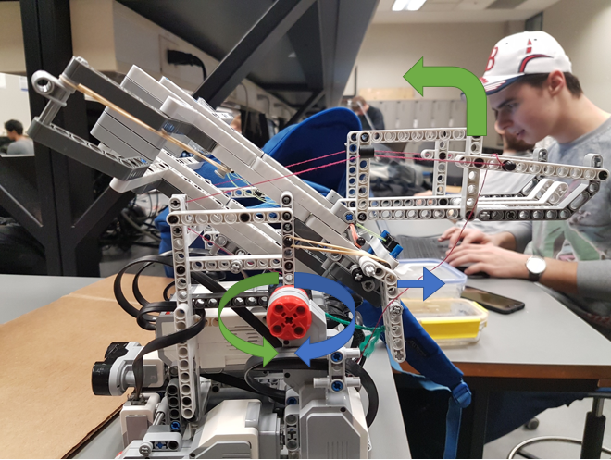

Figure 15

Figure 15: Trigger mechanism (blue arrow) actioned by clockwise rotation of the motor and ball loading (green arrow) by a counter clockwise rotation.

# Defense mechanism

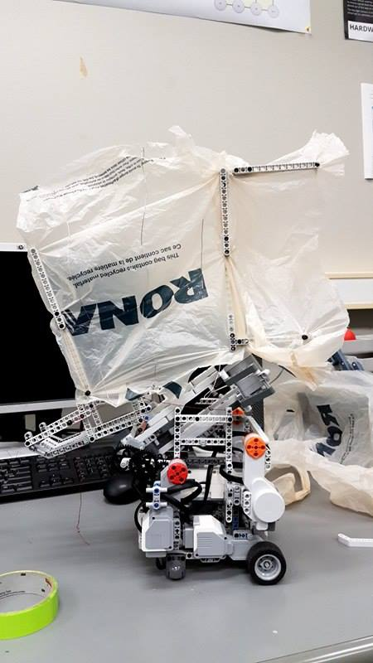Figure 16: We attached a plastic bag to the main frame of the robot and the reloading mechanism. The plastic bag covers a great area, but folds if necessary to allow corner localization.

Figure 16

# APPENDIX B

## Construction Reports

**Ball Reloading and Reservoir Mechanism**

Done by Romain Nith on the 27/03/17 – Corrected by Nayem (04/04/17)

Problem: To reduce the distance traveled by the robot, we need to design a reservoir to store the balls retrieved at the ball dispenser. The reservoir will store and reload the crossbow at the same time.

### Version 1

By traveling, the robot is prone to errors and is not expected to arrive at the ball dispenser perfectly. To prevent the robot from not being able to retrieve any ball, the reservoir would look like a funnel feeding the ball into a rail that leads directly to the firing chamber.

To pull up the entire system, a pulley mechanism with a string is being used. The string will be winded by the same motor used to pull on the crossbow trigger. It has been designed to not pull on the trigger when a ball is being dropped to the chamber: rotating clockwise will lift the reservoir and counter clockwise will pull on the trigger while lifting slightly but not enough to roll a ball into the chamber.

Iteration 1:

The reservoir’s floor is being made with Lego blocks

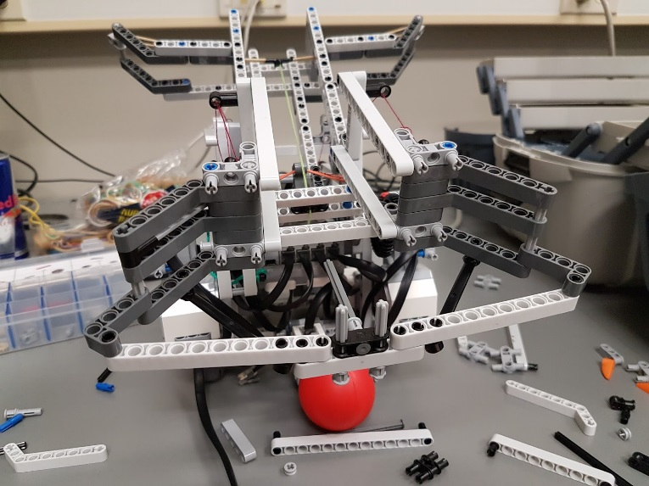

Issue: the reservoir is too large and balls would get stuck

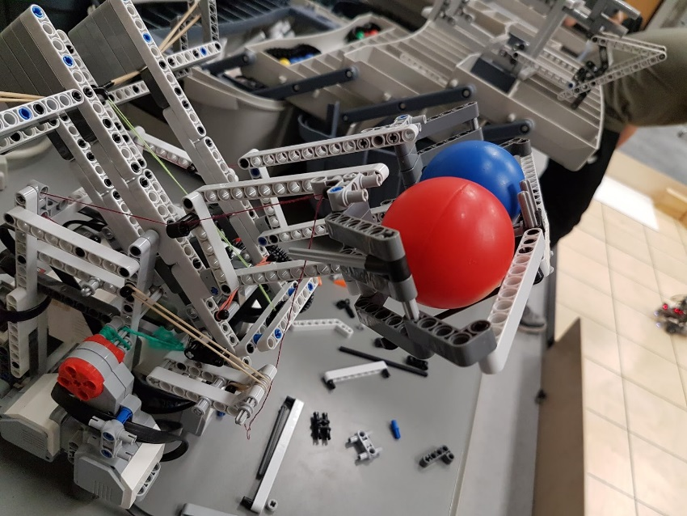

Iteration 2:

Change the reservoir to lift the height of the floor so the balls would fall into the rails more easily. Floor is being made out of paper.

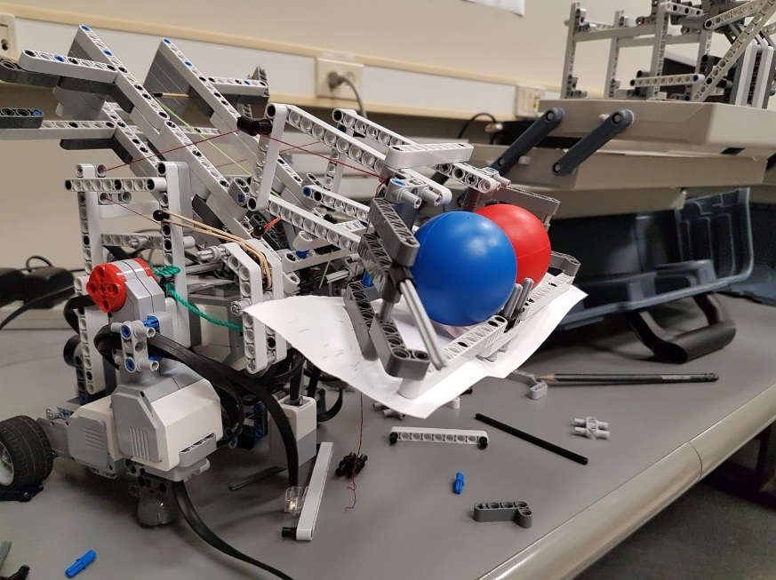

Issue: reservoir still too large and balls would get stuck

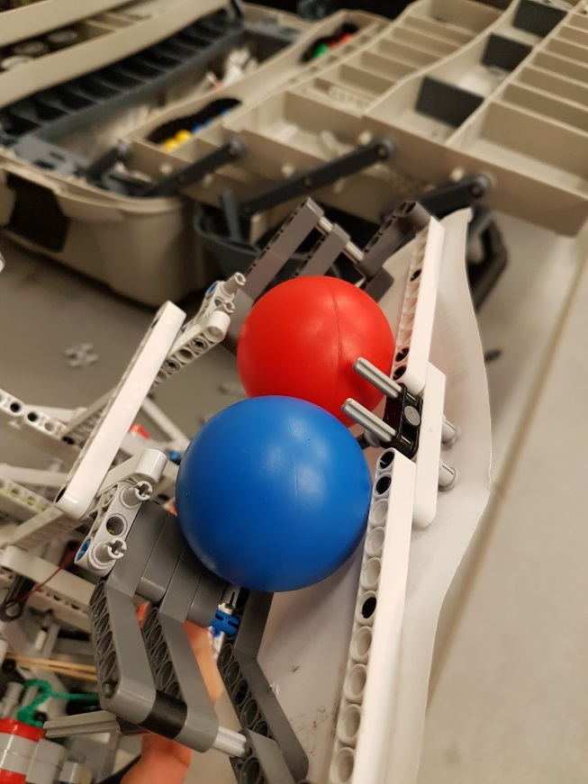

Iteration 3:

Reduce the extension of the funnel’s exterior arms

Issue: reservoir still too large and balls would get stuck

### Version 2

Assume the robot arrives at the dispenser with only plus or minus 2cm of error. Instead of a funnel, the robot would only have a large rail so the balls just stay aligned and are directly in the main rail ready to be dropped into the firing chamber.

Iteration 1:

Using the same rail of the previous version.

Issue: the opening isn’t wide enough and the robot has to be precisely under the dispenser to retrieve the ball

Iteration 2:

Shortening the upper rail for a wider opening.

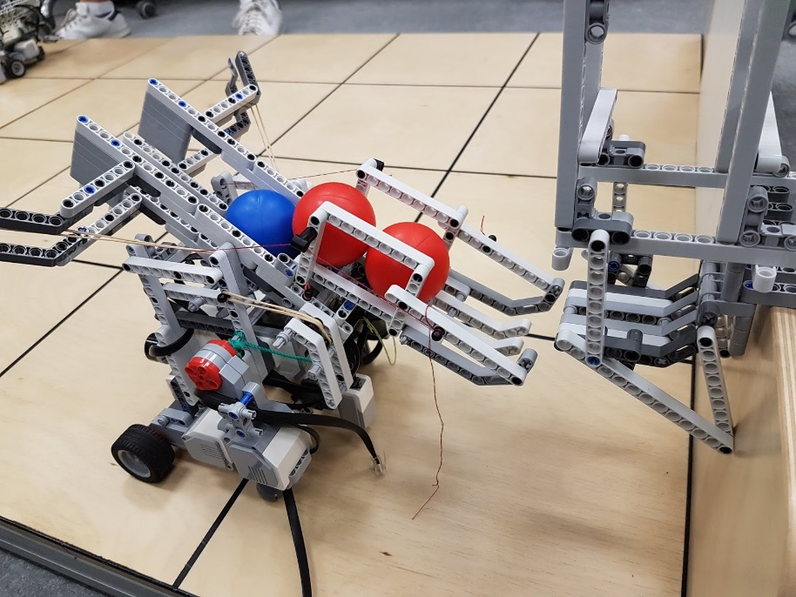

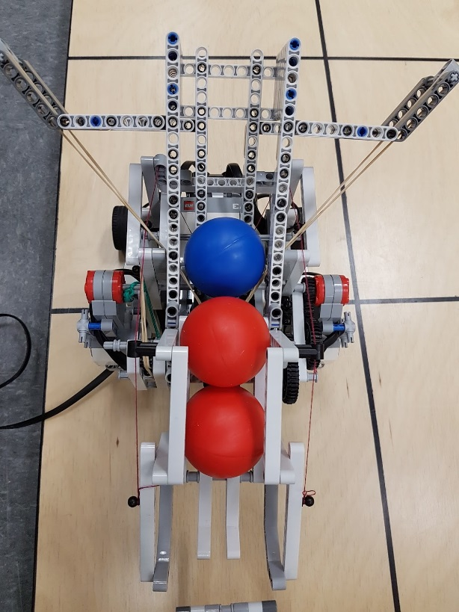

Result

The system works with [2.8; 3.3] cm of errors according to Dispenser Test document.